## Test task

Need to create the following component:

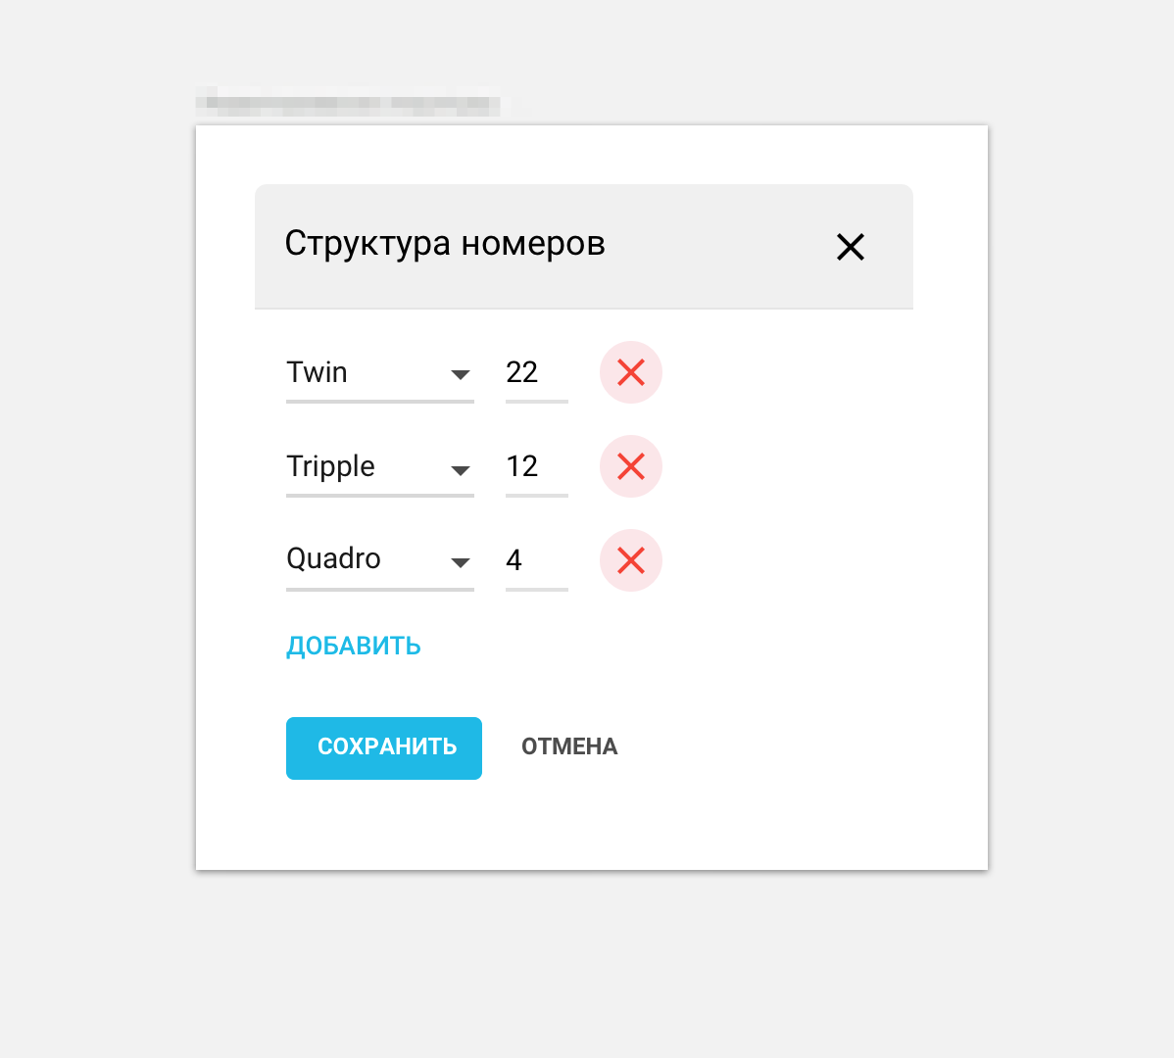

**Description**:

Modal popup window, which has on header a text title and close button. In a body we have a dynamic form, which consists from the dynamic list of elements.

Each Element consists of SelectBox, InputField(type=Number) and Delete button. If user clicks on Delete button, element will be removed from the list.

Below dynamic list we have a Create button to create new element in the list.

When User clicks on Save button, popup will be closed and params will be passed to initial object. Cancel button just closes the window as and Close icon on a top.

**Requirements**:

* Need to use <http://www.material-ui.com/> UI Kit as a core of UI elements.
* All UI Elements should use Material Design
* Component should be demonstrated uses <https://github.com/storybooks/react-storybook>